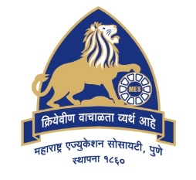

MAHARASHTRA EDUCATION SOCIETY'S

(SINCE 1860)

**INSTITUTE OF MANAGEMENT & CAREER COURSES (IMCC)**

Approved by AICTE and Recognized by Savitribai Phule Pune University, Pune

131, Mayur Colony, Kothrud, Pune 411038, Maharashtra, India | Ph.: 020-2546 6271 / 73 | e-mail: [info.imcc@mespune.in](mailto:info.imcc@mespune.in) | <https://imcc.mespune.in/>

**NAAC Accredited with Grade A+**

**Ref. No. MES IMCC / 399/ 2023 – 24/ Date:13/04/2024**

CERTIFICATE

This is to certify that the Project Report entitled

# “WorkBees”

is prepared by

# Krushna Santosh Chaudhari.

M.C.A. Semester IV Course for the Academic Year 2023-24 at M.E. Society's Institute of Management & Career Courses (IMCC), Pune - 411038.

M.C.A Course is afﬁliated to Savitribai Phule Pune University.

To the best of our knowledge, this is original study done by the said student and important sources used by him/her have been duly acknowledged in this report.

The report is submitted in partial fulﬁllment of M.C.A Course for the Academic Year 2023-24 as per the rules and prescribed guidelines of Savitribai Phule Pune University.

## Dr. Ravikant Zirmite



Head, Dept of MCA MES IMCC

## Dr. Santosh Deshpande

Director, MES IMCC

## Internal Examiner

## External Examiner

Head Ofﬁce: 'MES Bhavan', 1214-1215, Sadashiv Peth, Pune - 411030, Maharashtra, India. | Ph.: +91-020-41038100 | [www.mespune.in](http://www.mespune.in/)